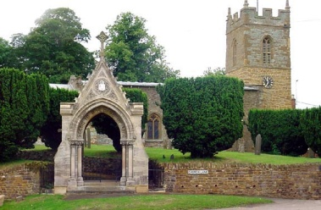
COLD ASHBY
ANNUAL PARISH ASSEMBLY
Wednesday 9th May 2018

The annual Cold Ashby Parish Assembly will take place on Wednesday 9th May at 7.30 p.m. in the Sports Pavilion, Stanford Road.
Everyone on the electoral register for Cold Ashby is welcome to attend. The meeting provides an opportunity to discuss matters of common or individual interest relating to the welfare and development of our community. Anything decided formally at the meeting will be reported directly to the relevant local bodies, including the Parish Council, and will carry the weight of a resolution from an officially constituted meeting.
Agenda
1. Election of chairman for the meeting (if the Parish Council chairman is present he will assume the chair automatically)
2. Apologies for absence
3. Minutes of the 2017 assembly
4. Welcome and introduction – the chairman will explain the purpose and nature of the meeting.
5. Chairman’s report – the chairman of the parish council will give a brief report on the work and achievements of the council in 2016-17 and look forward to activity in the coming year.
6. Cold Ashby Parish Environment Group (Capeg) – general discussion
7. Northampton Communities Foundation – windfarm fund. Explanation and discussion
8. Black Horse: new owners and plans for the future.
9. Defibrillator
10 Euro Garages and plans for Junction 1 on A14
11. Councillor Vacancy
12. Reports from District and County Councillors if present
13. Open Forum – an opportunity to raise further matters of general or individual interest relating to the community.

G Jones
CAPC clerk May 2018

